**The National Institute of Engineering**

(An Autonomous Institution under Visvesvaraya Technological University, Belagavi)

Manandawadi Road, Mysuru – 570008

**AICTE Activity on:**

# “Awareness about different stream available for higher education & Career opportunities”

**Submitted by:**

**RAVI N – 4NI19EE082**

**Under the Guidance of:**

ASHWINI G

Coordinator, Assistant Professor,

Electrical & Electronics. Department

## DEPARTMENT OF E&E ENGINEERING

The National Institute of Engineering

Manandawadi Road, Mysuru – 570008

**Acknowledgement**

We would like to thank our guide Ms. Ashwini G for encouragement in our activity, whose cooperation and guidance helped us throughout.

We would also like to extend our thanks to Mr. Shashikant Raj URS (Principal, Ashok Puram Government School, Mysore) for their effort and endurance to bring out the best in us.

**Abstract**

In a country like India, where illiteracy and poverty go together, being a volunteer teacher will not only give you a chance to meaningfully contribute towards the lives of the underprivileged children but also enable you to understand their daily struggles and how they survive despite the scarcity of the basic necessities.

Community service is unpaid work performed by individuals for the benefit and betterment of their community without any form of compensation. Also known as volunteering, it is a voluntary act of an individual or group freely giving time and labour.

**Brief Information of the activity**

The AICTE activity points refer to the points that are awarded by AICTE to every engineering student for completing activities prescribed by it.

As a part of this, we undertook and successfully completed an activity for the prescribed duration of Eighty hours. The activity that we undertook was to provide the students of class in the “GOVERNMENT HIGH SCHOOL, ASHOKPURAM” the Career guidance. We conducted this activity from 15/12/2022 to 30/12/2022. This activity was conducted as a team which consisted of twelve members.

**Career Guidance**

Two weeks of career guidance and different activities were conducted by us. As we are addressing students of class 8 to 10, Setting the basics right solves a lot of confusions that might arise later. Whether it is choosing the correct stream to the correct board, and mapping career goals, a right start at the right time makes all the difference.

We started by introducing ourselves and our purpose there. Then we asked the students to introduce themselves along with their interested subjects and professions.

There we got the count of future doctors, engineers, teachers, scientists, soldiers, police officers, lawyers etc.

Briefing about the importance of education in one’s life, we motivated students about the values, opportunities that one gets through education. We also insisted on how to prepare for board exams, methodology to study and tried to eliminate the fear of board exams.

Later we jumped into the main agenda, i.e., what after 10th ?. These include PUC or Diploma or ITI or other options, stream to join in, selection of college etc. The focus is given to PUC.

We started describing about the streams available as Science, Commerce, Arts and the available combinations there with the future opportunities waiting with regard to each.

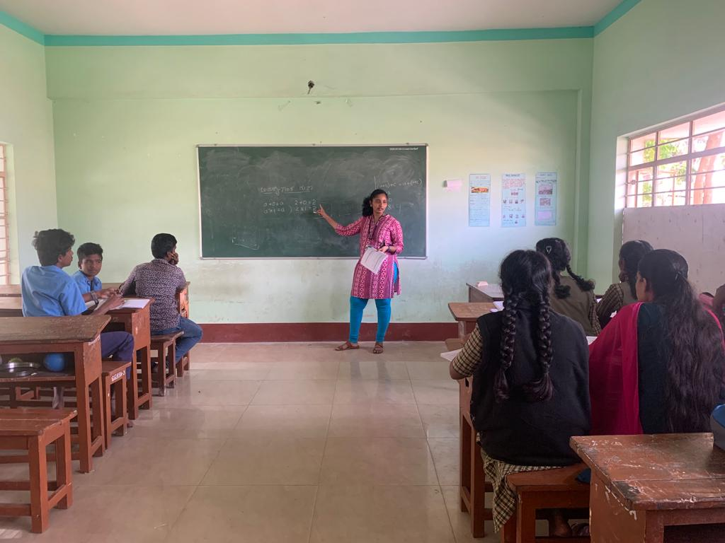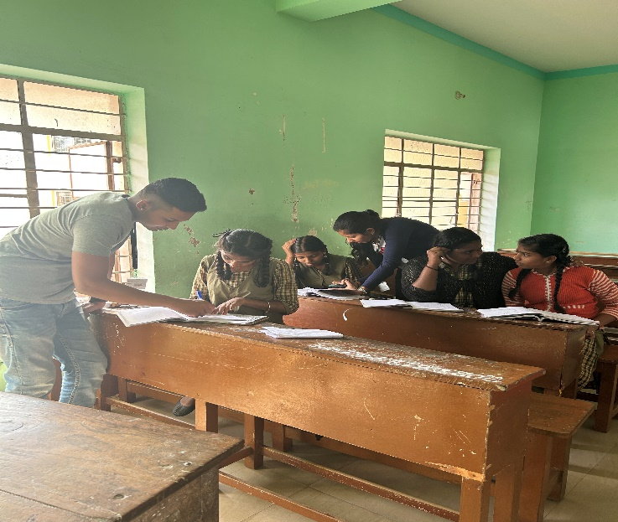

**Critical Thinking**

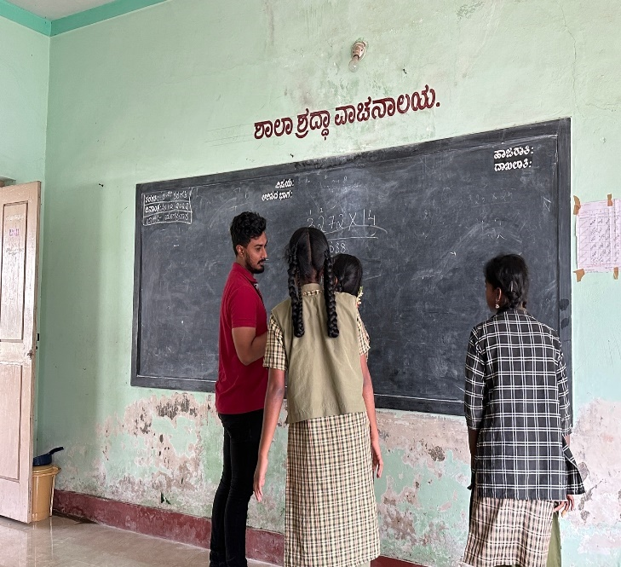

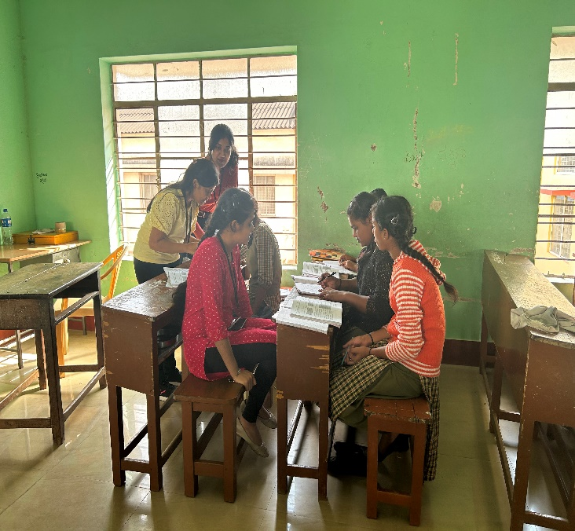

The students of different classes were tested on their critical thinking by asking them simple questions to solve. These puzzles helped kids to improve their cognitive abilities and also turned out to be enjoyable at the same time.

Kids loved to solve the puzzles and showed great interest in solving them. They also showed great competitive spirit while doing so which made these activities even more worthwhile for us.

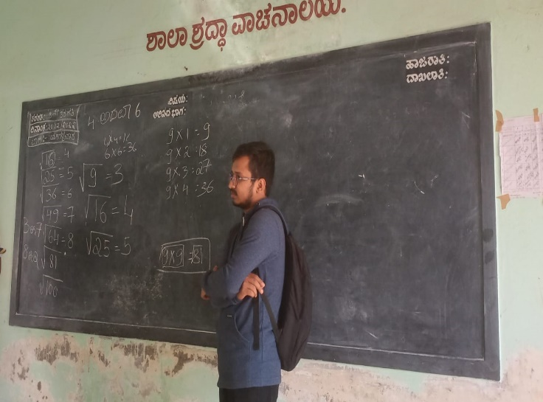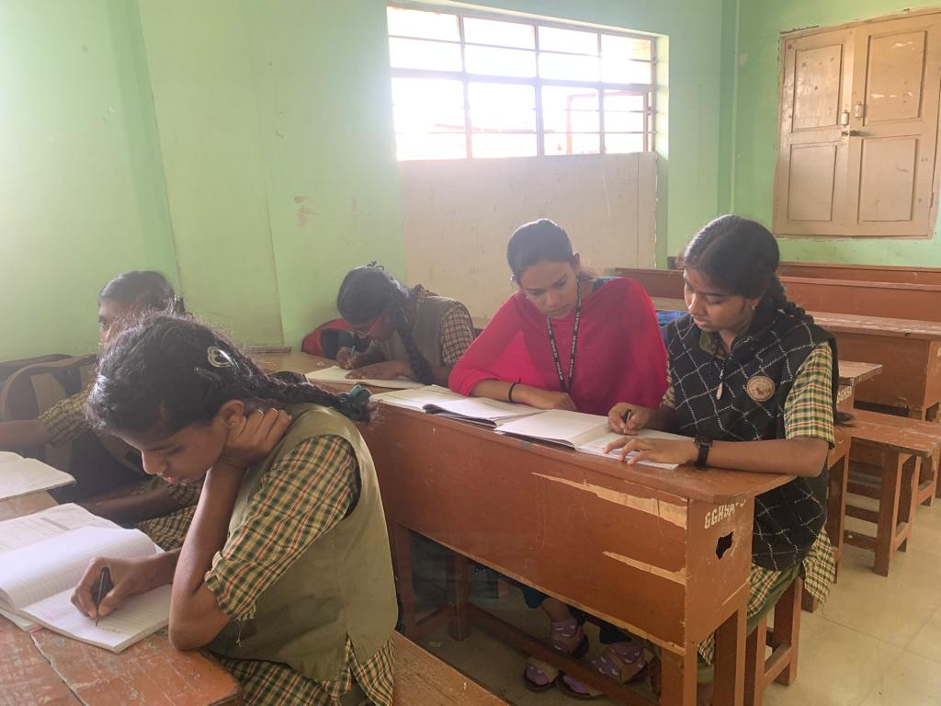

As a child we all had our own dreams which we

wished to turn to reality like the saying goes, "never let age extinguish the fire of your inner child". It is evident that almost everyone gives up their childhood aspiration as they grow up, to take up their childhood aspiration as they grow up, to take up something they never wished for. Generally looking into India Job satisfaction statistics of 2021, we can see that more than half of the population are not happy with their own jobs. First and foremost is the lack of resources and the gender stereotypes. So, to mould up these young aspiring kids by giving them proper guidance making them realize their true passion in life is very important. To make them believe in themselves and give them the confidence to pursue at such an age is necessary. Thus, accordingly the kids here showed great desire in their own dreams.

We were very happy to make a small contribution towards making the students at the school happy by distributing chocolates. The in-charge of the school was very much happy to see this initiative taken by us.

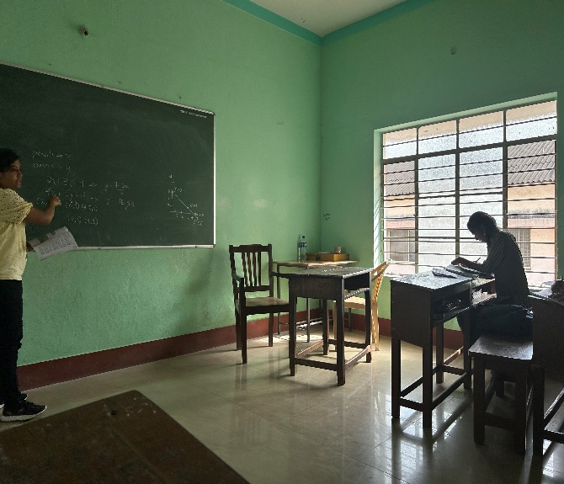

**Conclusion**

To teach is to learn as they say, during this activity not only did we realize the difficulties of being a teacher but also discern the significance of education. The environment in the public school was very different as compared to the environment in private school.

We have experienced culture change, adjustments, and new students to handle. The attitudes of the students were also different compared to that of students in the private schools. We were able to face the reality of being a public teacher. We genuinely appreciate all the people we have encountered, especially the students.

We will never forget our experiences. We have learned a lot and we are craving for more wisdom to be bestowed upon us.

